**Unconventional Housing Creations**

**Hierarchical model**

The PetSolutions Database is structured in a hierarchical model, organized around key tables with interconnected relationships.

1. **PetFriendlyHousingSolutions:**
   * Central table with a key field: ProductID.
   * Contains attributes such as ProductName, ProductCategory, PetType, Theme, BioSafeMaterials, TechnologyComponents, ThemedAccessories.
2. **SupplyChainNetwork:**
   * Linked to PetFriendlyHousingSolutions through ProductID.
   * Key field: SupplyChainID.
   * Attributes include RawMaterialName, SupplierName, Quantity, UnitPrice, DeliveryDate.
3. **Customers_Solutions:**
   * Connects CustomerBase and PetFriendlyHousingSolutions.
   * Key fields: CustomerID, ProductID.
4. **CustomerBase:**
   * Key field: CustomerID.
   * Attributes encompass CustomerName, PetType, PetAge, Address, PhoneNumber.
5. **PetSolutions_Customers:**
   * Establishes a connection between PetFriendlyHousingSolutions and CustomerBase.
   * Key fields: ProductID, CustomerID.
6. **NetworkArchitectureModel:**
   * Ties together CoreTeam and SupplyChainNetwork.
   * Key fields: EmployeeID, SupplyChainID.
   * Attributes include NetworkComponent, IPAddress, Description.
7. **CoreTeam:**
   * Connected to PetFriendlyHousingSolutions through ProductID.
   * Key field: EmployeeID.
   * Attributes cover EmployeeName, Designation, StartDate, Salary.

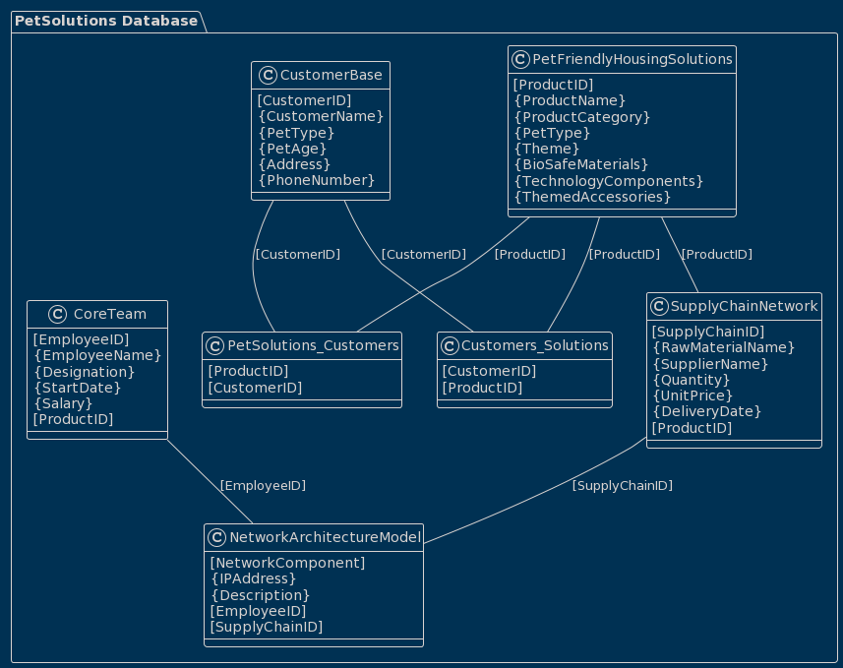

**ERD Model**

The ERD for the PetSolutions Database showcases entities and their connections:

1. **CoreTeam:**
   * Linked to PetFriendlyHousingSolutions.
2. **CustomerBase:**
   * Connects to Customers_Solutions.
3. **Customers_Solutions:**
   * Mediates between CustomerBase and PetFriendlyHousingSolutions.
4. **NetworkArchitectureModel:**
   * Relates to CoreTeam and SupplyChainNetwork.
5. **PetFriendlyHousingSolutions:**
   * Linked by relationships with CoreTeam, Customers_Solutions, PetSolutions_Customers, and SupplyChainNetwork.
6. **PetSolutions_Customers:**
   * Connects PetFriendlyHousingSolutions and CustomerBase.
7. **SupplyChainNetwork:**
   * Linked to PetFriendlyHousingSolutions.

The ERD illustrates how entities interact, providing a visual representation of the database structure.

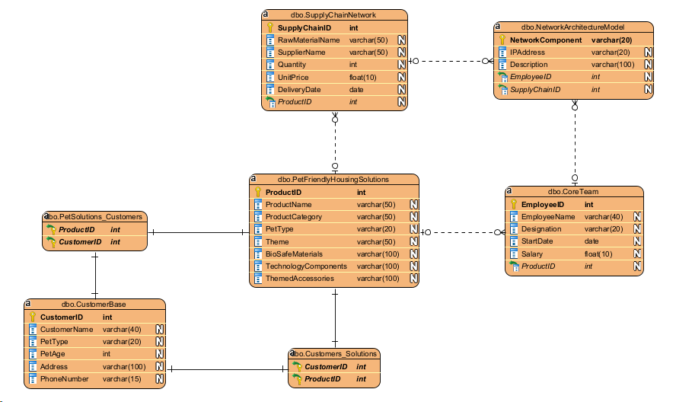

The relationships among the entities:

1. **Pet-Friendly Housing Solutions**:
   * **Related to Customer Base**: Many-to-many relationship (Customers may purchase multiple housing solutions; each solution may be bought by multiple customers)
2. **Core Team**:
   * **Related to Pet-Friendly Housing Solutions**: One-to-many relationship (Team members contribute to designing, manufacturing, and promoting various pet houses)
3. **Supply Chain Network**:
   * **Related to Pet-Friendly Housing Solutions**: One-to-many relationship (Supplies are used to create the housing solutions)
4. **Network Architecture Model**:
   * **Related to Core Team**: One-to-one relationship (Infrastructure components managed by the IT team)
   * **Related to Supply Chain Network**: One-to-one relationship (IT infrastructure likely used for supply chain management)
5. **Customer Base**:
   * **Related to Pet-Friendly Housing Solutions**: Many-to-many relationship (Customers purchase various housing solutions; each solution can be bought by multiple customers)

These relationships showcase how the different elements are interlinked and dependent on one another for the business to function efficiently.